WITHINGTON METHODIST CHURCH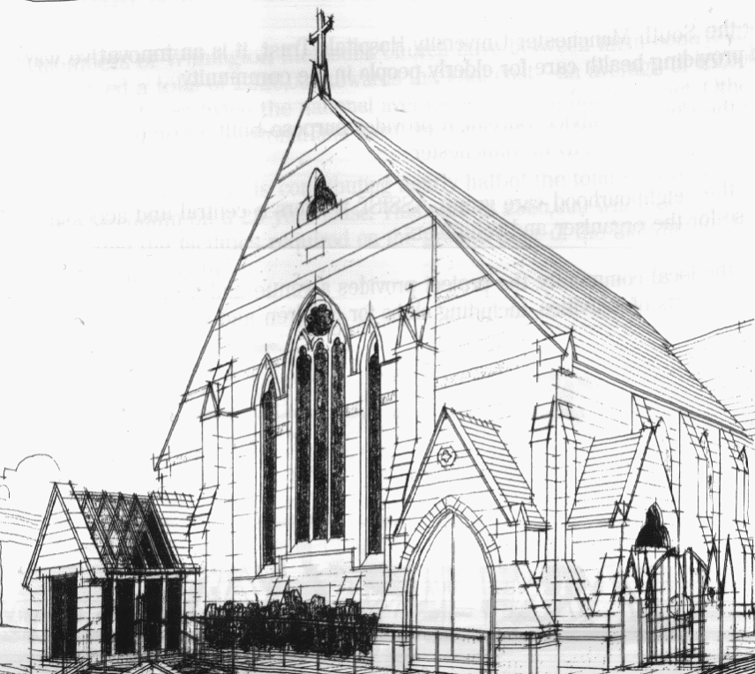
439 Wilmslow Road, Withington, Manchester, M20 4AN.
Telephone: 0161 445 0804
E-MAIL: office@withingtonmethodistchurch.org

SUNDAY 6th March 2022

10:45 am: Morning worship led by Bernard Treves Brown

6:30 pm: Circuit service on Zoom led by Revd. Ken Stokes
New joining details - TBA

PRAYER CONCERNS

We continue to remember in our prayers…

The families of Kathleen, Elaine and Harold, Muriel, Jasibe, John, Marguerite, Helen Osei, Linda, Ora and Stasi, Henry, Promilla and family, Ukraine and Russia, Ukrainian refugees

CHURCH ACTIVITIES THIS WEEK

Monday 7th March, 11 am: Coffee morning on Zoom CANCELLED
Wednesday 9th March, 2 pm: Lenten Bible Study on Zoom

Joining details for the meeting:
https://us02web.zoom.us/j/84141198605
Meeting ID: 841 4119 8605

SUNDAY 13th March 2022

10:45 am: Morning worship led by Revd. Peter Went

6:30 pm: Circuit service on Zoom led by Revd. Ken Stokes or Matt Smith

CHURCH FAMILY NEWS

Our next Church Council meeting will take place on Monday 7th March at 7:30 pm in the Ground Floor Hall. At the meeting Church Council members will make the decision about whether or not to register our premises for same-sex weddings.

