WITHINGTON METHODIST CHURCH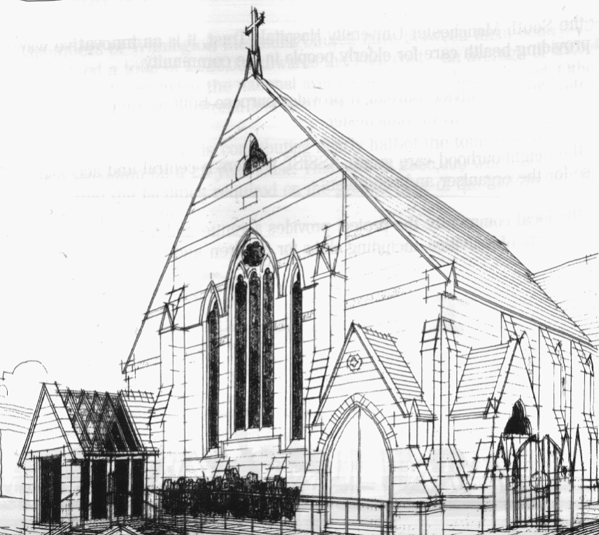
439 Wilmslow Road, Withington, Manchester, M20 4AN.
Telephone: 0161 445 0804
E-MAIL: office@withingtonmethodistchurch.org

THIRD SUNDAY OF LENT: 20th March 2022

10:45 am: Morning worship with Holy Communion led by Revd. Krystyna Kwarciak

6:30 pm: Circuit service on Zoom led by Revd. Ken Stokes

PRAYER CONCERNS

We continue to remember in our prayers…

Sarah, John, Marguerite, Helen Osei, Ora and Stasi, Henry, Promilla and family, the people of Ukraine and Russia, Ukrainian refugees in the UK

CHURCH ACTIVITIES THIS WEEK

Monday 23rd March, 2:00 pm: Coffee and chat on Zoom

Joining details for the meeting:
https://us02web.zoom.us/j/84141198605
Meeting ID: 841 4119 8605

FOURTH SUNDAY OF LENT: 27th March 2022

10:45 am: Morning worship led by Revd. Caroline Wickens

6:30 pm: Circuit service on Zoom led by Matt Smith

CHURCH FAMILY NEWS

Revd. Caroline Wickens has sent the following message to share with you all:

The Rev. Catharine Hughes has been appointed to the circuit and will work with Didsbury, East Didsbury and Withington. Catharine comes to us at the beginning of her ministry as a probationer, and it is a great privilege to work with her through this time of her final formation as she prepares for ordination, normally after two years on probation. I’m sure that her churches will take delight in helping her grow and discover what it means to her to be a minister.

