WITHINGTON METHODIST CHURCH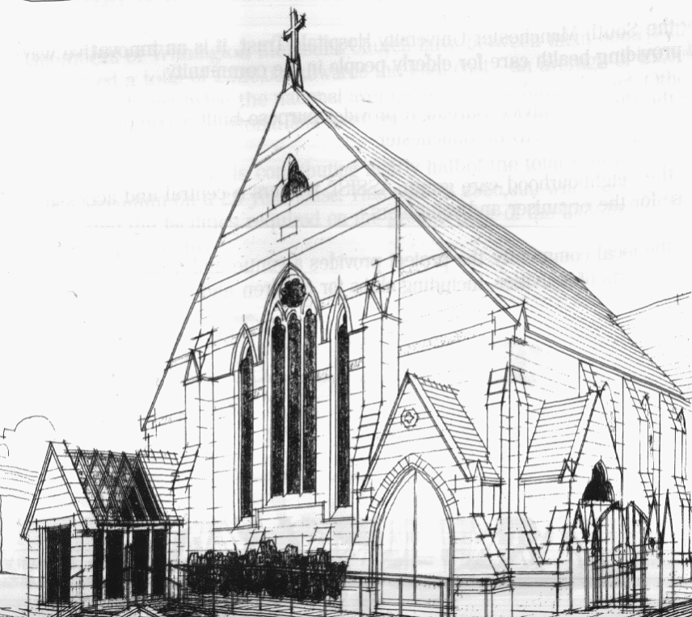
439 Wilmslow Road, Withington, Manchester, M20 4AN.
Telephone: 0161 445 0804
E-MAIL: office@withingtonmethodistchurch.org

ALDERSGATE SUNDAY 22nd May 2022

10:45 am: Morning worship with Holy Communion led by Revd. Krystyna Kwarciak

6:30 pm: Easter Offering Service on Zoom led by Methodist Women in Great Britain

PRAYER CONCERNS

We remember in our prayers…

The family of Marion, Roger and family, Muriel, Thandiwe, Sarah, John, Marguerite, Helen Osei, Ora and Stasi, Henry, Ukrainian refugees across the world, the work of Christian Aid

WEEKLY CHURCH ACTIVITIES

Our next Coffee, Chat and Bible Study on Zoom will take place on Wednesday 1st June at 2:00 pm
Joining details for the meeting:
https://us02web.zoom.us/j/84141198605

SUNDAY 29th May 2022

10:45 am: Morning worship led by Revd. Ade Kila

6:30 pm: Circuit service on Zoom led by Deacon Pru Cahill

CHURCH FAMILY NEWS

EASTER OFFERING on ZOOM this SUNDAY, 22nd May at 6:30 pm!
The Circuit Evening Zoom Service was prepared by the Methodist Women in Britain for the World Mission Fund and is centred around the theme: ‘Tell her story, tell our story.’ Joining details will be circulated via email.

TRIP TO EPWORTH organised by Methodist Women in Great Britain
There is a trip to Epworth planned for 11th June 2022, if you are interested in going please let Chris Gregory, Manchester and Stockport MWiB District President, know at chrisg7684@gmail.com by 29th May.

TOOLS FOR MISSION update
Tools for Mission is Christian charity that collects unwanted usable tools, refurbishes them, sorts them into trade tool kits and sends them to the developing world for livelihood creation. Thank you for all your generous donations to this charity. We are going to be closing down our collections of tools at the end of May.

PLATINUM JUBILEE PARTY
You are warmly invited to our Magical Afternoon with tea and cake on Thursday 2nd June 2:30 – 5:00 pm at Withington Methodist Church.
For tickets please contact Heather at heatherjsteward@yahoo.co.uk or 07773 015882.

