WITHINGTON METHODIST CHURCH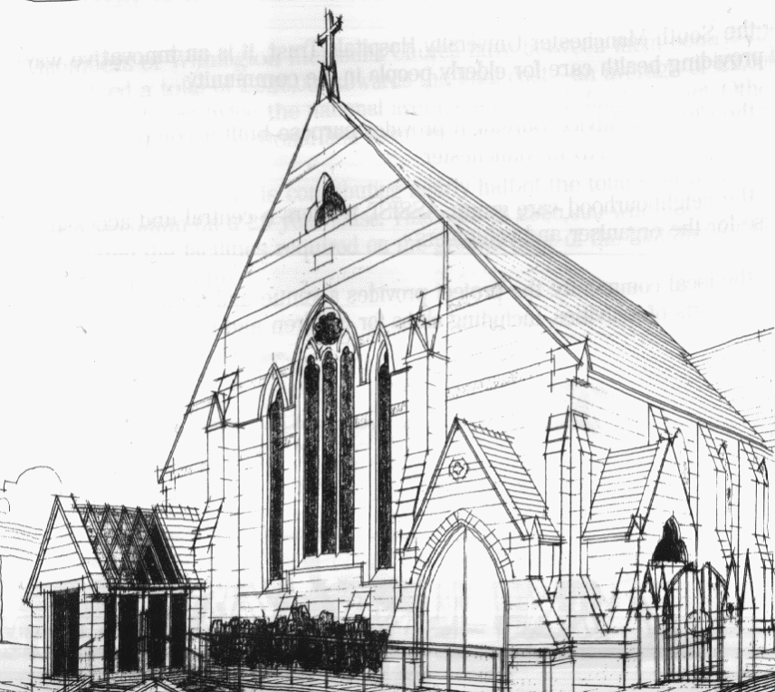
439 Wilmslow Road, Withington, Manchester, M20 4AN.
Telephone: 0161 445 0804
E-MAIL: office@withingtonmethodistchurch.org

SUNDAY 1st May 2022

10:45 am: Morning worship led by Revd. Krystyna Kwarciak

6:30 pm: Circuit service on Zoom led by Revd. Caroline Wickens

SUNDAY 8th May 2022

10:45 am: All Age Worship worship led by Abi Parr

6:30 pm: Circuit service on Zoom led by Matt Smith

SUNDAY 15th May 2022

10:45 am: Morning worship led by Pamela Sewart

6:30 pm: Circuit service on Zoom led by Revd. Joy Rulton

SUNDAY 22nd May 2022

10:45 am: Morning worship with Holy Communion led by Revd. Krystyna Kwarciak

6:30 pm: Easter Offering service on Zoom

PRAYER CONCERNS

We continue to remember in our prayers…

Thandiwe, Sarah, John, Marguerite, Helen Osei, Ora and Stasi, Henry, the people of Ukraine and Russia, Ukrainian refugees

CHURCH ACTIVITIES THIS WEEK

Revd. Krystyna Kwarciak will be on annual leave 2nd – 20th May. Revd. Caroline Wickens will be available to respond to any urgent issues that may arise at Withington while she is away. The weekly Bible Study on Zoom will resume after 21st May.

CHURCH FAMILY NEWS:

BOOK CLUB

The Book Club will next be meeting on Thursday 5th May at 7.30 pm, and this month’s book is:
“The Girl With The Louding Voice” by Abi Dare.
We welcome any new members! If you are interested, speak to Helen Fielding or Heather Steward, or just turn up!

URGENT: Could you be our next Church Council Secretary?

We are looking for a new Church Council secretary, someone who would:

1. Maintain a list of members of Church Council, who are the Managing Trustees of the local church, including their contact details.
2. Plan the agenda for Church Council meetings together with the Minister as Chairperson.
3. Take the Minutes of Church Council meetings and distribute them afterwards.
4. Plan the agenda for the annual General Church Meeting (AGM), including nominations for officeholders and representatives to Church Council.
5. Take the Minutes of General Church Meetings and distribute them afterwards.

For more details, please get in touch with Rev. Krystyna.
CHRISTIAN AID WEEK: May 15th - 21st
Every year Christian aid has a special week to gather in donations for their work all over the world
This year we will be doing a Delivery Only Christian Aid Envelope Collection to some local streets. We will not be going back to collect the envelopes (except by special request). Volunteers are needed to deliver these envelopes. They will be available in church on Sundays May 8th and 15th. They should be delivered during Christian Aid Week itself.
There will also be a collection plate in Church for Christian Aid, or you may give on-line to our E-envelope using the QR code next to the plate and in the May magazine.
BOOK OPEN DAY
Revd. Ian Mutton would like to invite you to a Book Open Day at home on Tuesday 24th May. Ian has decided that the time has come to pass on his book collection, so please feel free to come, have a browse and a chat with him. For details (address, time etc.) please contact Ian’s daughter, Lesley, on: lesley048@icloud.com.

