WITHINGTON METHODIST CHURCH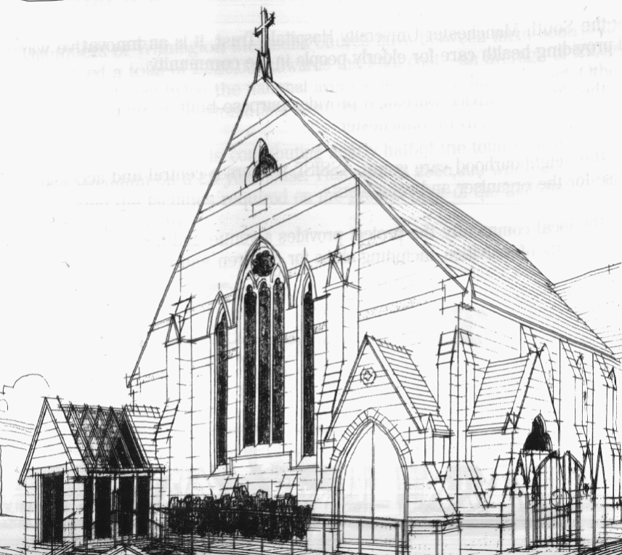
439 Wilmslow Road, Withington, Manchester, M20 4AN.
Telephone: 0161 445 0804
E-MAIL: office@withingtonmethodistchurch.org

SECOND SUNDAY OF LENT: 13th March 2022

10:45 am: Morning worship led by Revd. Peter Went

6:30 pm: Circuit service on Zoom led by Revd. Ken Stokes/Matt Smith

PRAYER CONCERNS

We continue to remember in our prayers…

Sarah, John, Marguerite, Helen Osei, Ora and Stasi, Henry, Promilla and family, the people of Ukraine and Russia, Ukrainian refugees

CHURCH ACTIVITIES THIS WEEK

Monday 14th March, 11 am: Coffee morning on Zoom CANCELLED
Wednesday 16th March, 2 pm: Coffee, Chat and Lenten Bible Study on Zoom

Joining details for the meeting:
https://us02web.zoom.us/j/84141198605
Meeting ID: 841 4119 8605

THIRD SUNDAY OF LENT: 20th March 2022

10:45 am: Morning worship with Holy Communion led by Revd. Krystyna Kwarciak

6:30 pm: Circuit service on Zoom led by Revd. Ken Stokes

CHURCH FAMILY NEWS

On 7th March our Church Council unanimously voted to register
Withington Methodist Church as a venue for same-sex weddings.
Our Options Appraisal Meeting will take place on Monday 14th March at 7:00 pm in church, in the Ground Floor Hall. All Church Council members are welcome to attend.

