WITHINGTON METHODIST CHURCH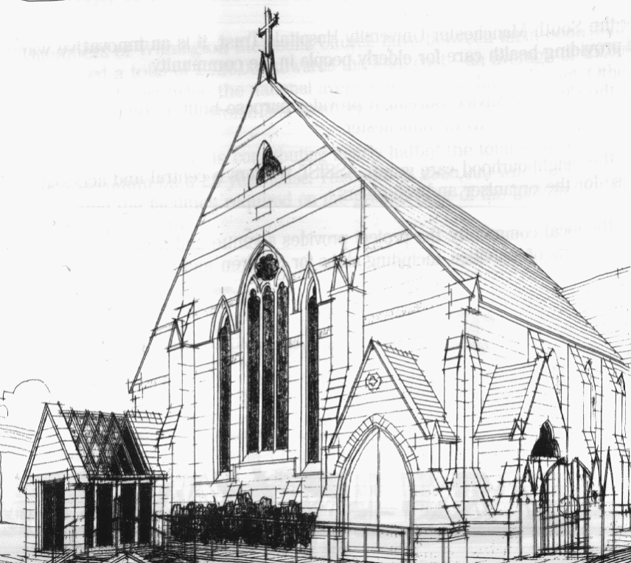
439 Wilmslow Road, Withington, Manchester, M20 4AN.
Telephone: 0161 445 0804
E-MAIL: office@withingtonmethodistchurch.org

SIXTH SUNDAY OF LENT: 10th April 2022

10:45 am: Livestreamed All Age Worship led by Nick Palfreyman

6:30 pm: Palm Sunday circuit service on Zoom led by Revd. Krystyna Kwarciak

PRAYER CONCERNS

We continue to remember in our prayers…

Thandiwe, Sarah, John, Marguerite, Helen Osei, Ora and Stasi, Henry, Promilla and family, the people of Ukraine and Russia, Ukrainian refugees in Poland

CHURCH ACTIVITIES THIS WEEK

Wednesday 13th April, 2:00 pm: Coffee, Chat and Lenten Bible Study on Zoom

Joining details for the meeting:
https://us02web.zoom.us/j/84141198605
Meeting ID: 841 4119 8605

EASTER SUNDAY: 17th April 2022

9 am: Easter Breakfast

10:45 am: Easter Sunday Service led by Liz Stuart

6:30 pm: Circuit service on Zoom with Holy Communion led by Revd. Sue Williams

CHURCH FAMILY NEWS

HOLY WEEK AND EASTER

On Good Friday will have a reflective ecumenical service from 10 am followed by the annual Walk of Witness starting at 11 am at Withington Methodist Church. We will be joined by our friends from L'Arche Withington, Saint Paul’s church, Union Chapel and Saint Cuthbert’s Roman Catholic church.

On Easter Sunday we will have a very special Easter Breakfast in church from 9 am. If you wish to attend, please let Heather know on: 01612837279, 07773015882 or heatherjsteward@yahoo.co.uk
If you are able to, please bring fresh flowers to be displayed on a cross during the morning service, and then shared both with absent friends and those attending.

