WITHINGTON METHODIST CHURCH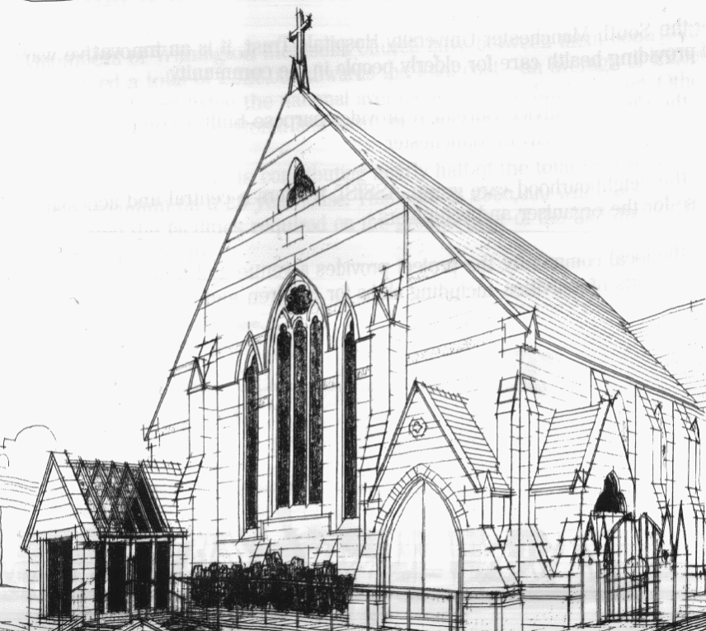
439 Wilmslow Road, Withington, Manchester, M20 4AN.
Telephone: 0161 445 0804
E-MAIL: office@withingtonmethodistchurch.org

SUNDAY 29th May 2022

10:45 am: Morning worship led by Revd. Ade Kila

6:30 pm: Circuit service on Zoom led by Deacon Pru Cahill

PRAYER CONCERNS

We remember in our prayers…

Roger and family, Muriel, Thandiwe, Sarah, John, Marguerite, Helen Osei, Ora and Stasi, Henry, Ukrainian refugees across the world, the work of Christian Aid

WEEKLY CHURCH ACTIVITIES

Our next Coffee, Chat and Bible Study on Zoom will take place on Wednesday 1st June at 2:00 pm
Joining details for the meeting:

https://us02web.zoom.us/j/84141198605

PENTECOST SUNDAY 5th June 2022

10:45 am: Morning worship – Local Arrangement

6:30 pm: Circuit service on Zoom led by Revd. Caroline Wickens

CHURCH FAMILY NEWS

SAVE THE DATE
Our next Church Council meeting will take place on Monday 6th June at 7:30 pm at church.
You are all warmly invited to our Annual General Meeting on Sunday 26th June after the service.

PLATINUM JUBILEE PARTY
You are warmly invited to our Magical Afternoon with tea and cake on Thursday 2nd June 2:30 – 5:00 pm at Withington Methodist Church.
For tickets please contact Heather at heatherjsteward@yahoo.co.uk or 07773 015882.

TRIP TO EPWORTH organised by Methodist Women in Great Britain
There is a trip to Epworth planned for 11th June 2022, if you are interested in going please let Chris Gregory, Manchester and Stockport MWiB District President, know at chrisg7684@gmail.com by 29th May.

