WITHINGTON METHODIST CHURCH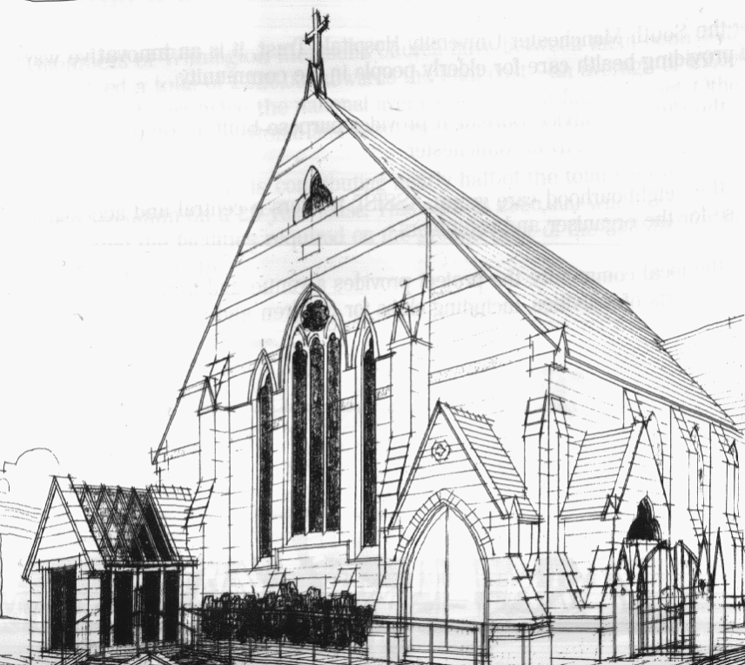
439 Wilmslow Road, Withington, Manchester, M20 4AN.
Telephone: 0161 445 0804
E-MAIL: office@withingtonmethodistchurch.org

SUNDAY 17th July 2022

10:45 am: Morning Worship focused around our partnership with the Methodist Church in Sekondi, Ghana led by Elizabeth Adu and Revd. Krystyna Kwarciak

6:30 pm: Circuit Farewell Service at Hope Methodist Church/Zoom led by Revd. Caroline Wickens

PRAYER CONCERNS

We remember in our prayers…

Thandiwe, Hanna, Donna and Kevin, Muriel, Sarah, John, Marguerite, Ora and Stasi, Henry

CHURCH ACTIVITIES

Our next Coffee, Chat and Bible Study on Zoom will be on Wednesday 20th July at 2:00 pm
Joining details for the meeting will be circulated by email.

SUNDAY 24th July 2022

10:45 am: All Age Worship led by Nick Palfreyman

6:30 pm: Circuit Service led by Revd. Caroline Wickens

CHURCH FAMILY NEWS

CIRCUIT FAREWELL SERVICE

The Circuit Farewell Service for Revd. Sue Williams, Matt Smith and Revd. Krystyna Kwarciak will be held on 17th July at 6:30 pm, at Hope Methodist Church. The service will be livestreamed so anyone can join in via Zoom.

KRYSTYNA’S LAST SERVICE AT WITHINGTON METHODIST CHURCH

On 31st July we will be saying goodbye to Rev. Krystyna who has been our minister for 5 years. As a farewell to Krystyna you are invited to bring your own picnic (cold food) which we will share after the service.

