WITHINGTON METHODIST CHURCH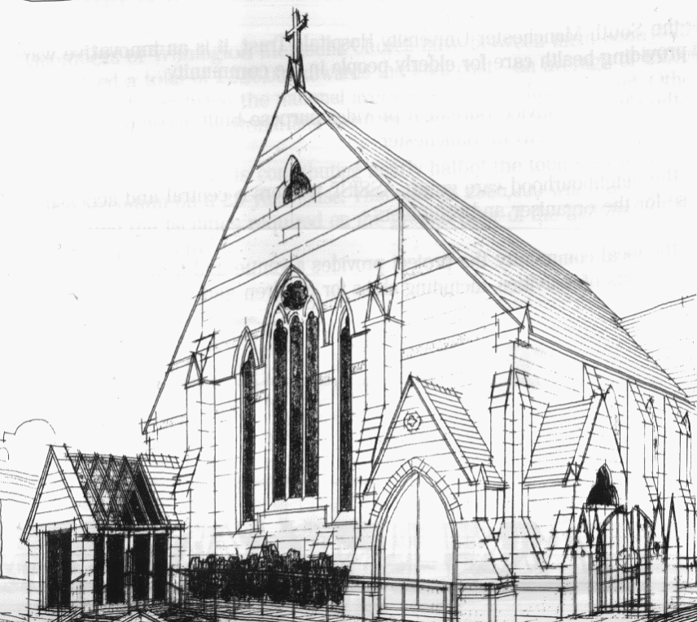
439 Wilmslow Road, Withington, Manchester, M20 4AN.
Telephone: 0161 445 0804
E-MAIL: office@withingtonmethodistchurch.org

SUNDAY 3rd July 2022

10:45 am: Local Arrangement Service

6:30 pm: Circuit Service on Zoom with Holy Communion led by Revd. Caroline Wickens

PRAYER CONCERNS

We remember in our prayers…

Hanna, Roger and family, Donna and Kevin, Muriel, Peter, Sarah, John, Marguerite, Ora and Stasi, Henry

CHURCH ACTIVITIES

Our next Coffee, Chat and Bible Study on Zoom will be on Wednesday 6th July at 2:00 pm

Joining details for the meeting will be circulated by email.

SUNDAY 10th July 2022

10:45 am: Morning Worship led by Abigail Parr

6:30 pm: Circuit Service on Zoom led by Revd. Sue Williams

CHURCH FAMILY NEWS

CHRISTIAN AID

WMC raised £122.33 during Christian Aid week. (£42.33 from church congregation donations and £80 from the e-envelope). It is unknown how much was sent directly to Christian Aid on-line from people receiving the delivery only envelopes that we delivered house to house.

Thank you to everyone who contributed with cash, help delivering envelopes or by praying.

CIRCUIT FAREWELL SERVICE

The Circuit Farewell Service for Revd. Sue Williams, Matt Smith and Revd. Krystyna Kwarciak will be held on 17th July at 6:30 pm, at Hope Methodist Church. The service will be livestreamed so anyone can join in via Zoom.

