WITHINGTON METHODIST CHURCH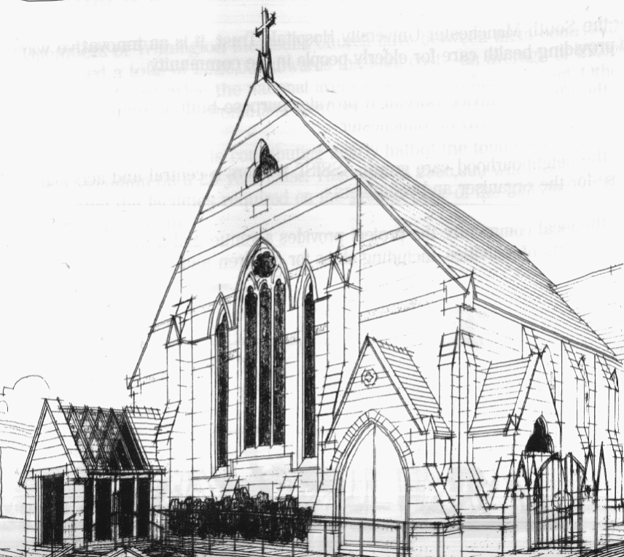
439 Wilmslow Road, Withington, Manchester, M20 4AN.
Telephone: 0161 445 0804
E-MAIL: office@withingtonmethodistchurch.org

SUNDAY 7th August 2022

10:45 am: Joint Worship with members of Levenshulme Methodist Church led by Revd. Anthony Clowes

6:30 pm: Circuit Service on Zoom led by Revd. Joy Rulton

PRAYER CONCERNS

We remember in our prayers…

Laurel Court and their chaplain, Alma, Thandiwe, Hanna, Donna and Kevin, Muriel, Sarah, John, Marguerite, Ora and Stasi, Henry

CHURCH ACTIVITIES

Our next Coffee, Chat and Bible Study on Zoom will be on Wednesday 10th August at 2:00 pm
Joining details for the meeting will be circulated by email.

SUNDAY 14th August 2022

10:45 am: Morning Worship led by Adrian Curtis

6:30 pm: Circuit Service on Zoom led by Revd. Ken Stokes

CHURCH FAMILY NEWS

Please note that there will be NO MORNING WORSHIP at Withington Methodist Church on Sunday 21st August. The service will be held at Levenshulme Methodist Church, 824 Stockport Rd, Levenshulme, Manchester, M19 3AW.

