WITHINGTON METHODIST CHURCH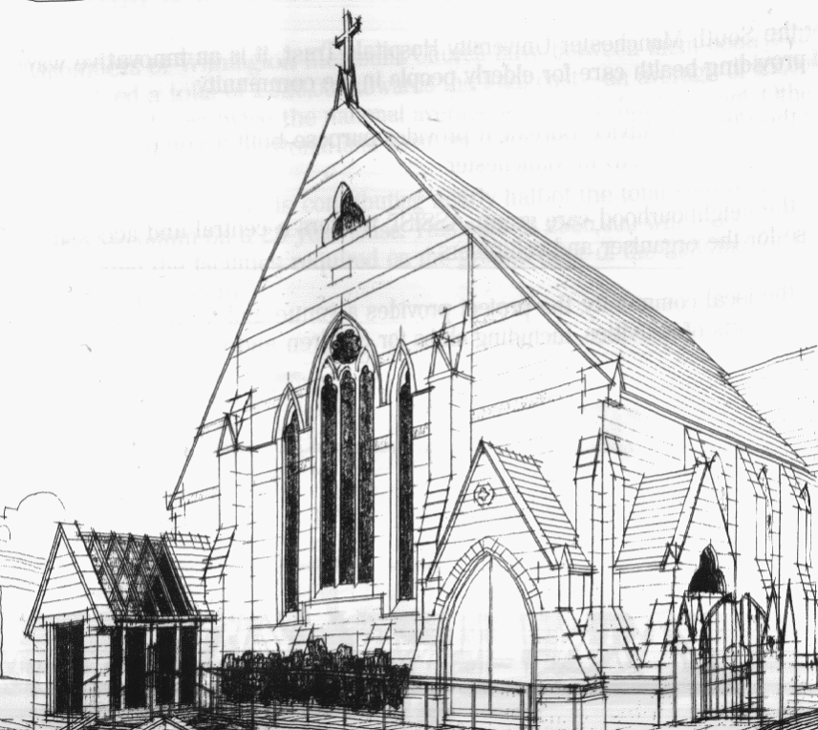
439 Wilmslow Road, Withington, Manchester, M20 4AN.
Telephone: 0161 445 0804
E-MAIL: office@withingtonmethodistchurch.org

SUNDAY 12th December 2021

10:45 am: Morning service led by Bernard Treves Brown

6:30 pm: Circuit service on Zoom led by Preachers in Training

PRAYER CONCERNS

We continue to remember in our prayers…

The family of Kathleen, the family of Sheila, Jasibe and family, Sylvain and Marlene, Muriel, Elaine, Thandi and Peter, John, Marguerite, Helen Osei, Linda, Ora and Stasi, Henry, Promilla and family

CHURCH ACTIVITIES THIS WEEK

Monday 13th December, 11 am: Coffee morning on Zoom CANCELLED
Wednesday 15th December, 2 pm: Coffee, Chat and short Advent Bible Study on Zoom

Joining details for Bible Study: https://us02web.zoom.us/j/84141198605
Meeting ID: 841 4119 8605

SUNDAY 19th December 2021

10:45 am: Carol Service led Eva Manley

6:30 pm: Evening service with Holy Communion on Zoom led by Revd. Caroline Wickens

CHURCH FAMILY NEWS

You are warmly invited to our Carol Service on 19th December led by Eva Manley.
The service will be livestreamed on YouTube and followed by refreshments: coffee, tea and mince pies.
Our Christmas Day service this year will start at 10:00 am and be led by Revd. Peter Went. There will be no service on Sunday 26th December.

