WITHINGTON METHODIST CHURCH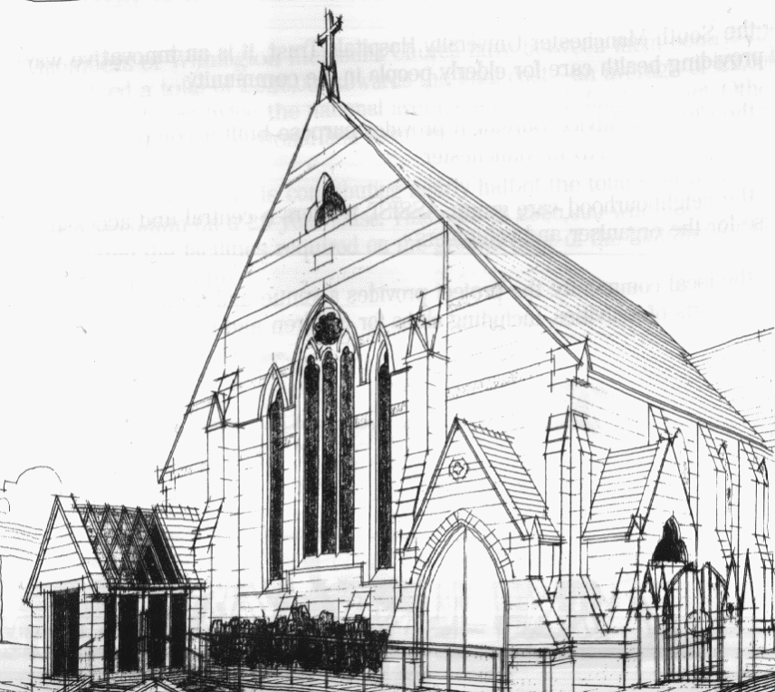
439 Wilmslow Road, Withington, Manchester, M20 4AN.
Telephone: 0161 445 0804
E-MAIL: office@withingtonmethodistchurch.org

SUNDAY 24th April 2022

10:45 am: Morning worship with Holy Communion led by Revd. Krystyna Kwarciak

6:30 pm: Circuit service on Zoom led by Local Preachers in Training

PRAYER CONCERNS

We continue to remember in our prayers…

Thandiwe, Sarah, John, Marguerite, Helen Osei, Ora and Stasi, Henry, the people of Ukraine and Russia, Ukrainian refugees

CHURCH ACTIVITIES THIS WEEK

Wednesday 27th April, 2:00 pm: Coffee, Chat and Bible Study on Zoom

Joining details for the meeting:
https://us02web.zoom.us/j/84141198605

SUNDAY 1st May 2022

10:45 am: Morning worship led by Revd. Krystyna Kwarciak

6:30 pm: Circuit service on Zoom led by Revd. Caroline Wickens

CHURCH FAMILY NEWS

BOOK CLUB

The Book Club will next be meeting on Thursday 5th May at 7.30 pm, and this month’s book is:
“The Girl With The Louding Voice” by Abi Dare.
We welcome any new members! If you are interested, speak to Helen Fielding or Heather Steward, or just turn up!

URGENT: Could you be our next Church Council Secretary?

We are looking for a new Church Council secretary, someone who would:

1. Maintain a list of members of Church Council, who are the Managing Trustees of the local church, including their contact details.
2. Plan the agenda for Church Council meetings together with the Minister as Chairperson.
3. Take the Minutes of Church Council meetings and distribute them afterwards.
4. Plan the agenda for the annual General Church Meeting (AGM), including nominations for officeholders and representatives to Church Council.
5. Take the Minutes of General Church Meetings and distribute them afterwards.

For more details, please get in touch with Rev. Krystyna.

